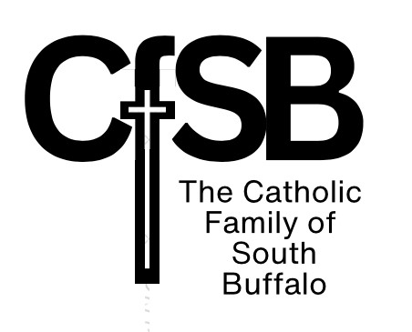
Please check location:
Our Lady of Charity:
Holy Family &
St. Ambrose
St. Martin of Tours
St. Teresa
Our Lady of Perpetual Help

Family Name ______________Registration Date _______
Mailing Address
Head of Household DOB
Phone Number Email
Occupation Religion ___________________________
Sacraments Received: Baptism ______ Confirmation ______
Married Date Married Place of Marriage ______________
Spouse DOB
Phone Number Email
Occupation Religion
Sacraments Received: Baptism ______ Confirmation ______
Child Birthdate School Attending
Sacraments Received
Child Birthdate School Attending
Sacraments Received
Child Birthdate School Attending
Sacraments Received
Will you be using envelopes? Y N Do you wish to sign up for Online Giving? Y N
Ministry interest
Would you like to volunteer for fund raising Y N Area
NOTES:

